EQUI JOIN EXAPMLES.

Non-equi join : display the invalid data.

Natural Join :

SQL> SELECT E.\*, D.DNAME

2 FROM EMP E, DEPT D

3 WHERE JOB='SALESMAN' AND E.DEPTNO=D.DEPTNO;

EMPNO ENAME JOB MGR HIREDATE SAL COMM

---------- ---------- --------- ---------- --------- ---------- ----------

DEPTNO DNAME

---------- --------------

7844 TURNER SALESMAN 7698 08-SEP-81 1500 0

30 SALES

7654 MARTIN SALESMAN 7698 28-SEP-81 1250 1400

30 SALES

7521 WARD SALESMAN 7698 22-FEB-81 1250 500

30 SALES

EMPNO ENAME JOB MGR HIREDATE SAL COMM

---------- ---------- --------- ---------- --------- ---------- ----------

DEPTNO DNAME

---------- --------------

7499 ALLEN SALESMAN 7698 20-FEB-81 1600 300

30 SALES

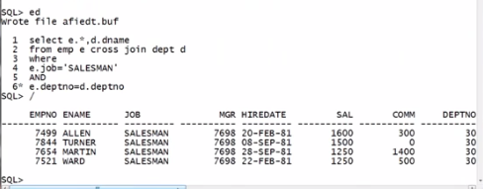

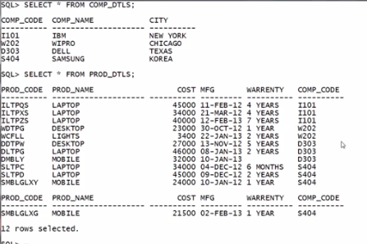

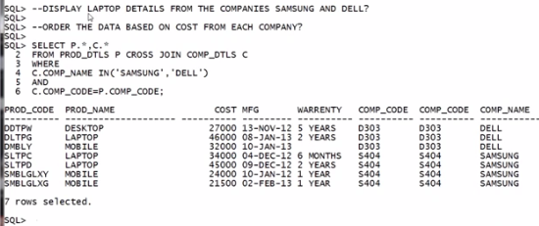

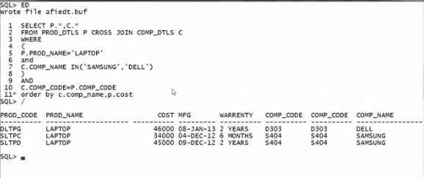

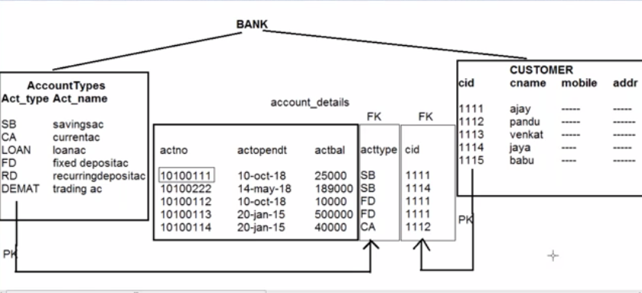

Parent table child table parent table.

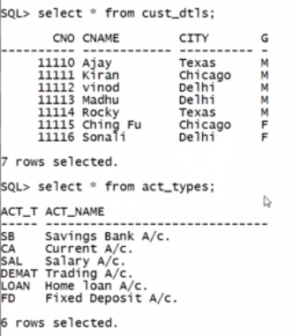

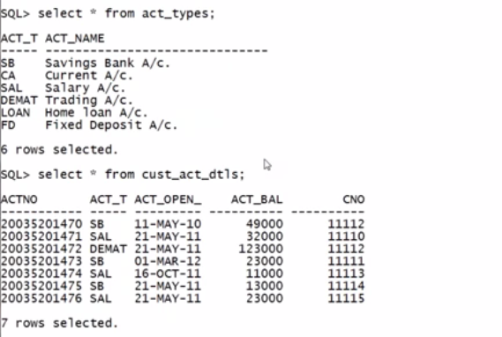

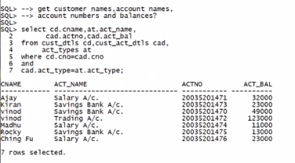

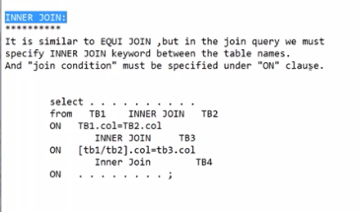

Output for inner join and equi join is same then what is the use of inner join .

There is a case where we need to use both outer join and equi join.

In that cases, we get a confusion in usage of where clause , if we use inner join On, and Where

We can have clarity.

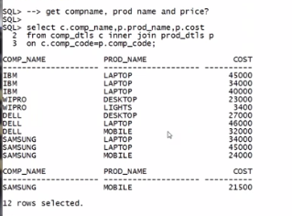

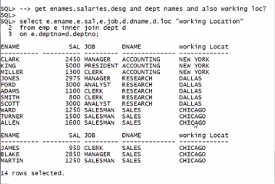

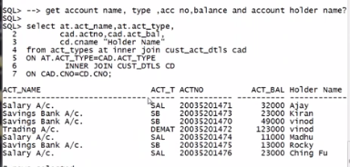

NON EQUI JOIN :

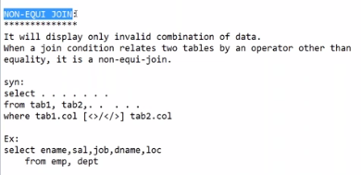

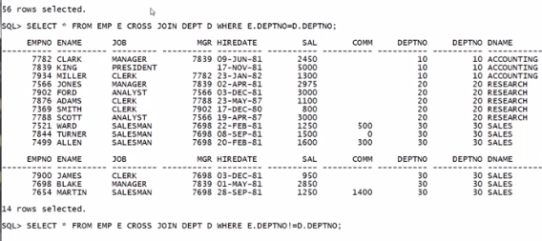

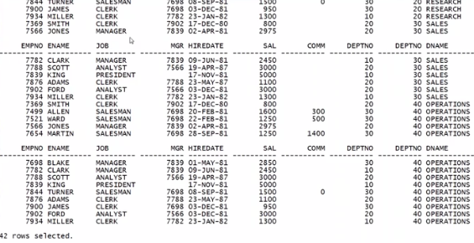

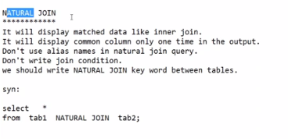

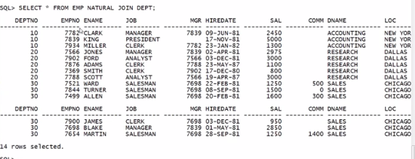

Common column will be displayed once , that is also at the beginning of the output.

